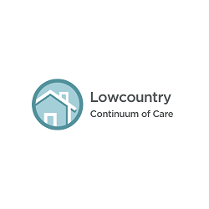

HUD FY2023 Continuum of Care Notice of Funding Opportunity

Lowcountry CoC Submission Timeline

July 5, 2023 | CoC NOFO released and available at https://www.grants.gov/web/grants/search-grants.html?keywords=continuum%20of%20care
August 1, 2023 | Local Release of Funding Availability (RFA) issued along with funding timeline and Project Threshold Criteria.
August 25, 2023 | All Project Applications are due in e-snaps and a PDF version plus attachments due by 5:00pm to Heather Carver at hcarver@lowcountrycoc.org.
August 31, 2023 | Project review, scoring and ranking completed by the Project Selection Committee.
September 8, 2023 | Notification sent to all applicants if their application is going to be included in the CoC Consolidated Application Submission. If an application is not included in the CoC Consolidated Application, a rejection letter will be emailed to the contact provided by the applicant.  Priority Ranking results posted for public review at https://lowcountrycoc.org/.
September 15, 2023 | Appeal letters, if any, are due to Heather Carver at hcarver@lowcountrycoc.org
September 25, 2023 | CoC Governing Council approves Consolidated Application.
September 26, 2023 | Consolidated Application posted for public review at https://lowcountrycoc.org/.
September 28, 2023 | Consolidated Application due to HUD by 8:00PM EST

